Technical Architecture:

Project Design Phase-II Technology Stack (Architecture & Stack)

|  |  |
| --- | --- |
| Date | 03 October 2022 |
| Team ID | PNT2022TMID14112 |
| Project Name | Plasma donor application |
| Maximum Marks | 4 Marks |

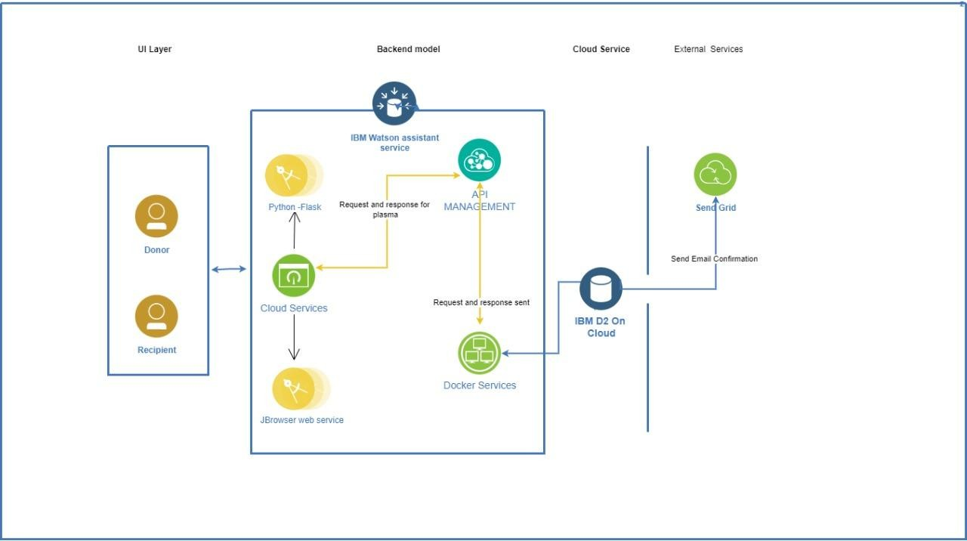

Table-1 : Components & Technologies:

|  |  |  |  |
| --- | --- | --- | --- |
| **S.No** | **Component** | **Description** | **Technology** |
| 1. | User Interface | * The user creates an account or registers in the UI. * Goes through the UI and view details | HTML, CSS,Python Flask |
| 2. | Chatbot | * Used to clarify user queries | IBM Watson Assistant |
| 3. | Data maintenance | For storing,maintaining,modifying and retrieving the user’s details | MySQL |
| 4. | Confirmation Email | Sending a confirmation email to users they have registered for donation and to check the availability  of plasma | SendGrid |
| 5. | Cloud Database | For storing the appointment ,donation details and user’s details | IBM DB2 |
| 6. | File Storage | File storage requirements | IBM Block Storage |
| 7. | Infrastructure (Server / Cloud) | To deploy an Application on Local System | Kubernetes |

Table-2: Application Characteristics:

|  |  |  |  |
| --- | --- | --- | --- |
| **S.No** | **Characteristics** | **Description** | **Technology** |
| 1. | Open-Source Frameworks | Python flask micro framework is used. | Python Flask |
| 2. | Security Implementations | Mandatory Control(MAC) and Kubernetes is used. | SHA-256, Encryptions, IAM Controls, OWASP ,Kubernetes |
| 3. | Scalable Architecture | 3-Tier architecture is used. | Web Server-HTML,CSS Application Server-Python Flask Database Server-IBM DB2 |
| 4. | Availability | Using Load Balancer to distribute network traffic across servers. | IBM Load Balancer |
| 5. | Performance | Request and respond facility within a second. User-friendly API | IBM Content Delivery Network |